**PYTHON RESULTS**

The step-by-step results of the python flow of the project is shown. To know in detail about the process followed, refer Chapter 3.1. The results here are shown with one image and a particular phrase is detected for which the meaning is extracted.

**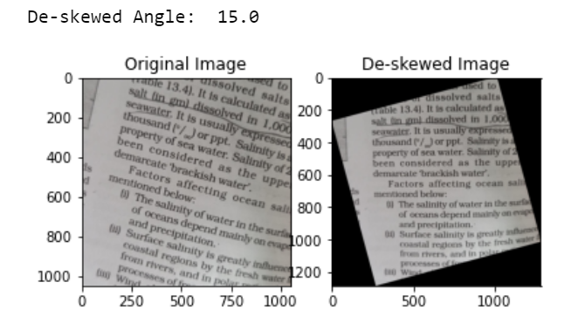***Fig 6.1.1: De-skewing & Straightening of Image*

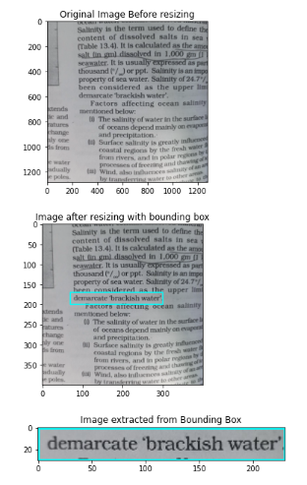

*Fig 6.1.2: 1. Original image 2. Re-sized and Bounding Box fixed 3. Bounding Box extracted*

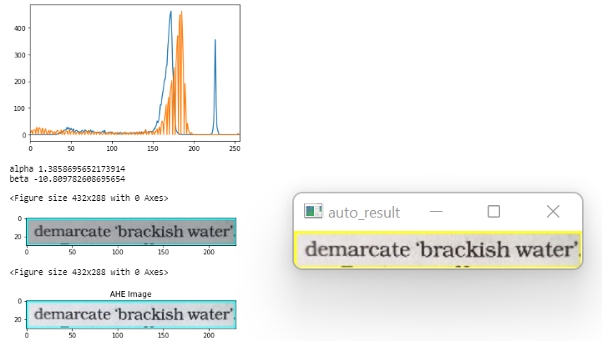

**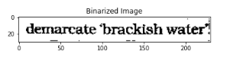***Fig 6.1.3: AHE & Binarization performed on extracted image with localized word*

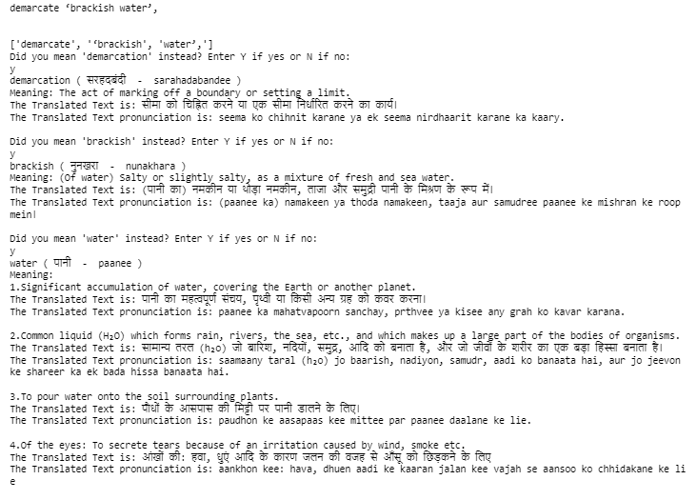

*Fig 6.1.4: Localized word is detected using Tesseract after processing.  
The meaning of the detected text along with input language incorporation is thrown as output*